Department of Computer Engineering
Object Oriented Programming

First 04 LAB-Manuals
Submitted by:

Name: Tahir Noor
Reg. no: 2025-CYS-170
Cyber Security
Sec-C (FALL-25)
Morning
2nd Semester

Submitted to:
Hafiz Muhammad Mubashar

Session: 25-29


University of Engineering and Technology, Lahore.

Table of Contents

Table of Contents …………………………………………………………….…..…… 01
Lab No. 01: Getting Started with Java …………………………………….…..….... 02
Lab No. 02: Core Concepts of Java/Fundamentals ………………........................... 08
Lab No. 03: Writing First Program in Java ………………………….……….…….. 17
Lab No. 04: Classes & Objects ………………………….……………………….……. 24

Lab Evaluation:

Course Name: Object Oriented Programming |  |  |  | Course Code: CMPE221L
Assignment Type: Lab |  |  |  | Dated: 16 February 2026
Semester: 2nd |  |  |  | Session: CYS 2025 Fall
Lab/Project/Assignment #: 1 |  |  |  | CLOs to be covered: CLO1
Lab Title: Getting Started with Java |  |  |  | Teacher Name: Mr. Shahmeer Nawaz
CLO 1 | Implement abstraction and encapsulation to develop reusable classes for objects of real-world problems
Levels (Marks) | Level 1 | Level 2 | Level 3 |  | Level 4 | Level 5 | Level 6
(10)
Total |  |  |  |  |  |  | /10

Rubrics for Current Lab Evaluation
Scale | Marks | Level | Rubric
Excellent | 9-10 | L1 | Submitted all lab tasks, BONUS task, have good understanding.
Very Good | 7-8 | L2 | Submitted the lab tasks but have good understanding
Good | 5-6 | L3 | Submitted the lab tasks but have weak understanding.
Basic | 3-4 | L4 | Submitted the lab tasks but have no understanding.
Barely Acceptable | 1-2 | L5 | Submitted only one lab task.
Not Acceptable | 0 | L6 | Did not attempt

LAB No.1
Lab Goals/Objectives:
Getting Started with Java

Acquiring practice with familiar programming constructs in JAVA

Equipment Required: Inteli J IDEA Edition Community, Net Beans with JDK 13 Version, Visual Studio.
Theory/Relevant Material: Write First Java Program
Lab Tasks:
- Change the Factorial code discussed in class so that it shows proper messaging in case of negative numbers.
- Change the Series_Generator such that it can generate both increasing series or decreasing series depending on the starting and ending values.
- Write a Program that takes year as an input from user and determine if it’s a leap year or not.
Sample input
>>>
Enter Any Year: 1940 It is a leap year

- You are interested in calculating your electricity bill of your home. You know the unit consumption of your home. Billing criteria for electric company is that it charges 5 Rs/ unit for first 100 units, next 100 units are charged at 7 Rs/unit and above that charge is 15 Rs/unit. As input, you get total_Units consumed and generate bill.
Sample input
>>>
Enter Units Consumed: 150 Bill: 850

- Write a program that takes an integer n from command-line arguments and uses a while loop to compute the number of times you need to divide n by 2 until it is strictly less than 1. Print the error message “Illegal input” if n is negative.
Sample input
>>> n: 8 Div: 4
>>> n: 4
Div: 3

- Write a code that takes a number value from user and displays the inverse of it. Number can be of any length.

Sample input
>>>
Number: 151
Inverse: 151
>>>
Number: 1567
Inverse: 7651

Lab no 1: Getting Started with Java

Task No. 1: Change the Factorial code discussed in class so that it shows proper messaging in case of negative numbers.

Solution:

import java.util.Scanner;

public class Lab_1_task1
{
public static void main(String []args)
{
Scanner a=new Scanner(System.in);
System.out.println("Enter a number:");
int n=a.nextInt();
if (n<0)
{
System.out.println("You enter a negative number");
}
else if(n==0)
{
System.out.println("Factorial of 0 is 1");
}
else
{
int fac=1;
for (int i=1; i<=n; i++)
fac = fac * i;
System.out.println("Factorial of " +n +" is " +fac);
}
}
}

Output:

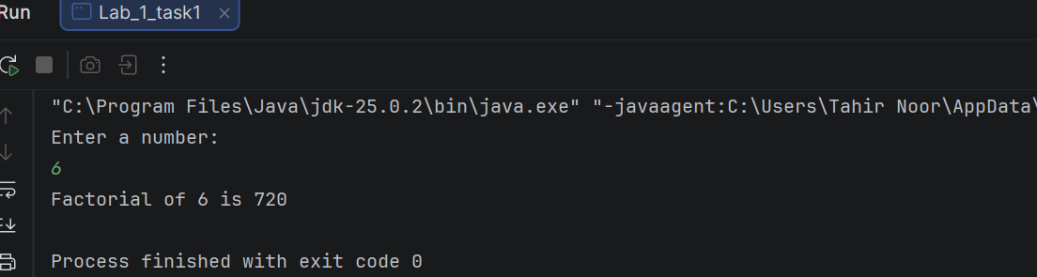

Task No. 2: Change the Series_Generator such that it can generate both increasing series or decreasing series depending on the starting and ending values.

Solution:
import java.util.Scanner;

public class Lab_1_task2 {
public static void main(String[] args) {
Scanner a = new Scanner(System.in);
System.out.println("Enter starting value:");
int x = a.nextInt();
System.out.println("You entered " + x);
Scanner b = new Scanner(System.in);
System.out.println("Enter ending value");
int y = b.nextInt();
if (y < x) {
for (int i = y; i <= x; i++) {
System.out.print(i + " ");
}
} else if (y > x) {
for (int i = y; i >= x; i--) {
System.out.print(i + " ");
}
} else {
System.out.print(b);
}
}
}

Output:

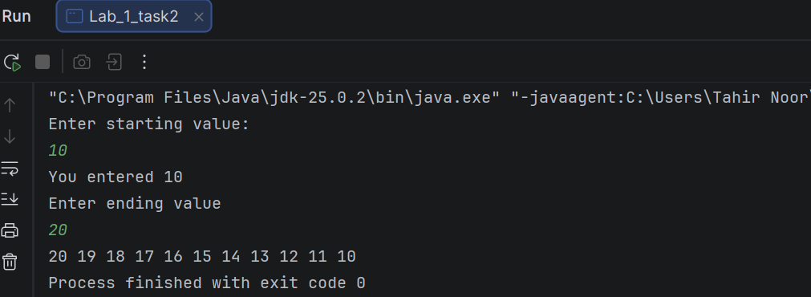

Task No. 3: Write a Program that takes year as an input from user and determine if it’s a leap year or not.
Sample input
>>> Enter Any Year: 1940
>>> It is a leap year

Solution:

import java.util.Scanner;

public class Lab_1_task3
{
public static void main(String[] args)
{
Scanner sc=new Scanner(System.in);
System.out.println("Enter a Year:");
int y=sc.nextInt();
{
if(y%4==0)
System.out.println(y+ " is a leap year");
else
System.out.println(y+ " is not a leap year");
}
}
}
Output:

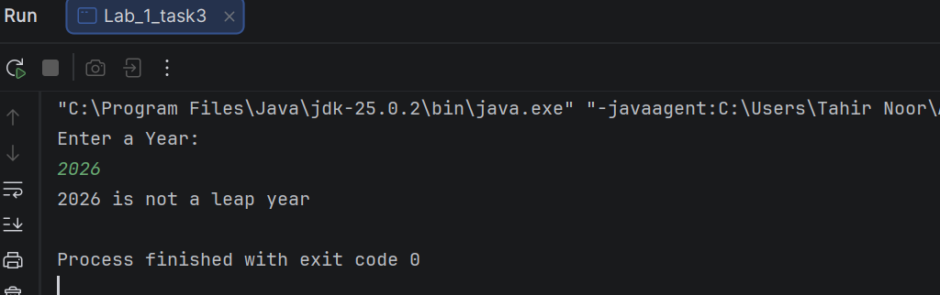

Task No. 4: You are interested in calculating your electricity bill of your home. You know the unit consumption of your home. Billing criteria for electric company is that it charges 5 Rs/ unit for first 100 units, next 100 units are charged at 7 Rs/unit and above that charge is 15 Rs/unit. As input, you get total_Units consumed and generate bill.
Sample input
>>>
Enter Units Consumed: 150
Bill: 850

Solution:

import java.util.Scanner;

public class Lab_1_task4
{
static void main(String[] args)
{
Scanner b=new Scanner(System.in);
System.out.println("Enter unit consumed:");
int u=b.nextInt();
int bill;
{
if(u<=100)
{
bill=u*5;
}
else if(u<=200)
{
bill=100*5+(u-100)*7;
}
else
{
bill=100*5+100*7+(u-200)*15;
}
System.out.println("Bill is " +bill);
}
}
}
Output:

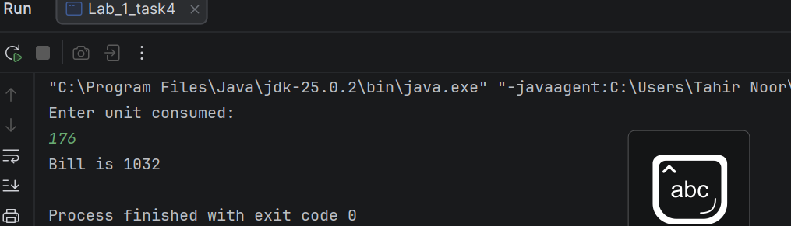

Task No. 5: Write a program that takes an integer n from command-line arguments and uses a while loop to compute the number of times you need to divide n by 2 until it is strictly less than 1. Print the error message “Illegal input” if n is negative.
Sample input
>>> n: 8 Div: 4
>>> n: 4 Div: 3

Solution:

import java.util.Scanner;

public class Lab_1_task5
{
public static void main(String[] args)
{
Scanner n = new Scanner(System.in);
System.out.println("Enter a number:");
int div = n.nextInt();
int count = 0;
if (div < 0)
System.out.println("Illegal input");
else
{
while (div != 1) {
div = div / 2;
count += 1;
}
System.out.println(count);
}
}
}

Output:

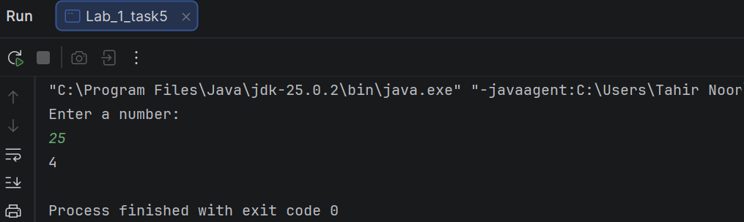

Task No. 6: Write a code that takes a number value from user and displays the inverse of it. Number can be of any length.
Sample input
>>>
Number: 151
Inverse: 151
>>>
Number: 1567
Inverse: 7651

Solution:

import java.util.Scanner;

public class Lab_1_task6
{
public static void main(String[] args)
{
Scanner a=new Scanner(System.in);
System.out.println("Enter a number:");
int r=a.nextInt();
int reverse=0;
while(r!=0)
{
int d=r%10;
reverse=reverse*10+d;
r=r/10;
}
{
System.out.println(reverse);
}
}
}

Output:

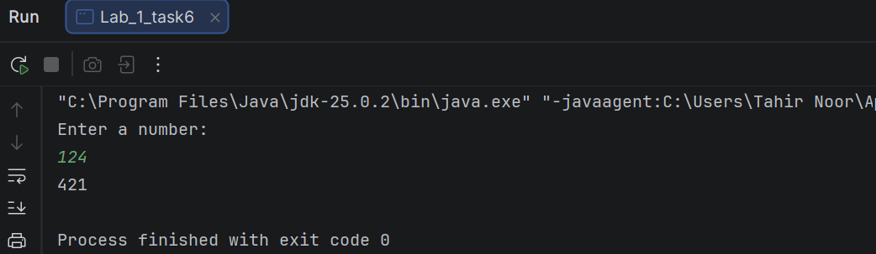

Lab Evaluation:

Course Name: Object Oriented Programming |  |  |  | Course Code: CMPE221L
Assignment Type: Lab |  |  |  | Dated: 23 February 2026
Semester: 2nd |  |  |  | Session: CYS 2025 Fall
Lab/Project/Assignment #: 2 |  |  |  | CLOs to be covered: CLO1
Lab Title: Core Concepts in Java / Fundamentals |  |  |  | Teacher Name: Mr. Shahmeer Nawaz
CLO 1 | Implement abstraction and encapsulation to develop reusable classes for objects of real-world problems
Levels (Marks) | Level 1 | Level 2 | Level 3 |  | Level 4 | Level 5 | Level 6
(10)
Total |  |  |  |  |  |  | /10

Rubrics for Current Lab Evaluation
Scale | Marks | Level | Rubric
Excellent | 9-10 | L1 | Submitted all lab tasks, BONUS task, have good understanding.
Very Good | 7-8 | L2 | Submitted the lab tasks but have good understanding
Good | 5-6 | L3 | Submitted the lab tasks but have weak understanding.
Basic | 3-4 | L4 | Submitted the lab tasks but have no understanding.
Barely Acceptable | 1-2 | L5 | Submitted only one lab task.
Not Acceptable | 0 | L6 | Did not attempt

LAB No.2
Lab Goals/Objectives:
Getting Started with Java

Acquiring practice with familiar programming constructs in JAVA

Core Concepts in Java / Fundamentals

Equipment Required: Inteli J IDEA Edition Community, Net Beans with JDK 13 Version, Visual Studio.
Theory/Relevant Material: Write First Java Program
Lab Tasks:
Task 1: The Geometry Calculator (Operators & Math)
Objective: Use Math methods and arithmetic operators.
• Create a program that stores the radius of a circle as a double.
• Calculate the area ($Area = \pi \times r^2$). Use Math.PI and Math.pow().
• Print the result. Then, use Type Casting to print the area as a whole integer.
Task 2: String Analysis Tool (Strings)
Objective: Manipulate and analyze text data.
• Create a String variable fullName containing your first and last name.
• Print the length of the string.
• Convert the name to all uppercase.
• Use indexOf() to find the position of the space between the names.
Task 3: Automatic Grade Converter (Type Casting) Objective: Practice Narrowing Casting and Output.
• Declare a double variable percentage = 85.99.
• Manually cast this percentage into an int.
• Print: "Your raw score is: 85.99% but your rounded grade is: 85%".
Task 4: The Logical Gatekeeper (Logical Operators) Objective: Use &&, ||, and !.
• Create two boolean variables: hasID and isOver18.
• Write an if statement that prints "Access Granted" only if both are true.
• Write another statement that prints "Special Guest" if they have an ID OR they are over 18.
Task 5: Random Number Matcher (Math & Booleans) Objective: Use Math.random() and comparisons.
• Generate a random number between 1 and 10. Hint: Use (int)(Math.random() * 11).
• Declare a variable userGuess = 5.
• Print true if the random number matches the guess, otherwise print false.

Task 6: Personalized Greeting (Strings & Concatenation) Objective: Use different methods of string joining.
• Create variables for greeting, firstName, and lastName.
• Use the + operator to join them for one output.
• Use the .concat() method to join them for a second output.

Task 7: Time-of-Day Identifier (If...Else If) Objective: Use conditional chains.
• Store an int variable hour (0 to 23).
• If hour is between 5 and 11, print "Good Morning".
• Else if hour is between 12 and 17, print "Good Afternoon".
• Else if hour is between 18 and 23, print "Good Evening".
• Use else to handle any other numbers as "Invalid Hour".
Task 8: The Currency Switcher (Switch Case) Objective: Practice multi-way branching.
• Create a variable String currency = "USD".
• Use a switch statement to print the full name of the currency:
o "USD" -> "United States Dollar"
o "GBP" -> "British Pound"
o "EUR" -> "Euro"
o Default -> "Unknown Currency" Task 9: Comparison & Increment Lab (Operators) Objective: Understand how values change.
• Declare int x = 10 and int y = 20.
• Use a comparison operator to print if x is not equal to y.
• Apply the increment operator ++ to x.
• Print the new value of x and check if it is now greater than 10.

Lab no 2 : Core Concepts of Java

Task No. 1:
The Geometry Calculator (Operators & Math)
Objective: Use Math methods and arithmetic operators.
• Create a program that stores the radius of a circle as a double.
• Calculate the area ($Area = \pi \times r^2$). Use Math.PI and Math.pow().
• Print the result. Then, use Type Casting to print the area as a whole integer.
Solution:

public class Lab_2_task1
{
public static void main(String[] args)
{
double r=8.5;
double a=Math.PI*Math.pow(r,2);
System.out.println("Area is " +a);
int A =(int) a;
System.out.println(A);
}
}
Output:

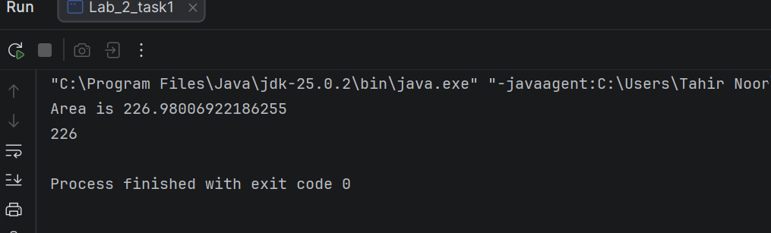

Task No. 2:
String Analysis Tool (Strings)
Objective: Manipulate and analyze text data.
• Create a String variable fullName containing your first and last name.
• Print the length of the string.
• Convert the name to all uppercase.
• Use indexOf() to find the position of the space between the names.
Solution:
public class Lab_2_task2
{
public static void main(String[] args){
String firstname="Tahir";
String lastname="Noor";
String fullname=firstname+" "+lastname;
System.out.println(fullname.length());
System.out.println(fullname.toUpperCase());
System.out.println(fullname.indexOf(" "));
}
}
Output:

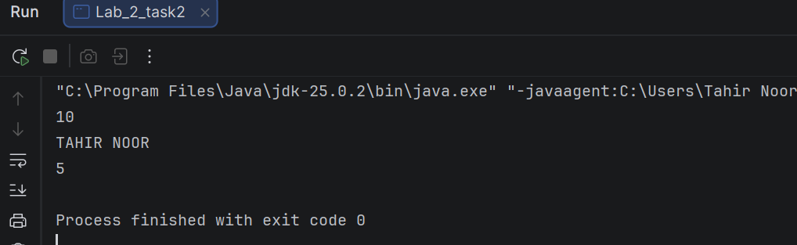

Task No. 3:
Automatic Grade Converter (Type Casting) Objective: Practice Narrowing Casting and Output.
• Declare a double variable percentage = 85.99.
• Manually cast this percentage into an int.
• Print: "Your raw score is: 85.99% but your rounded grade is: 85%".

Solution:

public class Lab_2_task3
{
public static void main(String[] args)
{
double percentage=85.99;
int a=(int) percentage;
System.out.println("Your raw score is " +percentage);
System.out.println("but your rounded grade is " +a);
}
}
Output:

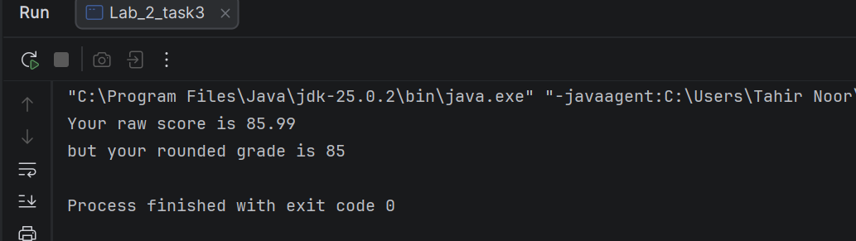

Task No. 4:
The Logical Gatekeeper (Logical Operators) Objective: Use &&, ||, and !.
• Create two boolean variables: hasID and isOver18.
• Write an if statement that prints "Access Granted" only if both are true.
• Write another statement that prints "Special Guest" if they have an ID OR they are over 18.
Solution:

public class Lab_2_task4
{
public static void main(String[] args)
{
boolean hasID=true;
boolean isOver18=true;
if (hasID&&isOver18)
{
System.out.println("Acess granted");
}
if(hasID||isOver18)
{
System.out.println("Special guest");
}
}
}
Output:

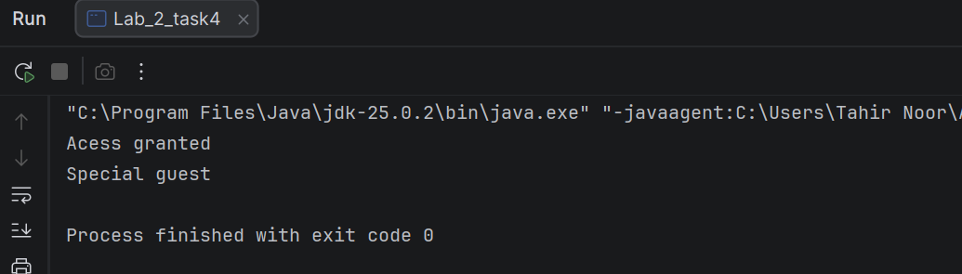

Task No. 5:
Random Number Matcher (Math & Booleans) Objective: Use Math.random() and comparisons.
• Generate a random number between 1 and 10. Hint: Use (int)(Math.random() * 11).
• Declare a variable userGuess = 5.
• Print true if the random number matches the guess, otherwise print false.

Solution:

public class Lab_2_task5
{
public static void main(String[] args)
{
int random_number=(int)(Math.random()*11);
int userguess=5;
{
if(random_number==userguess)
{
System.out.println("True");
}
else
{
System.out.println("false");
}
}
}
}
Output:

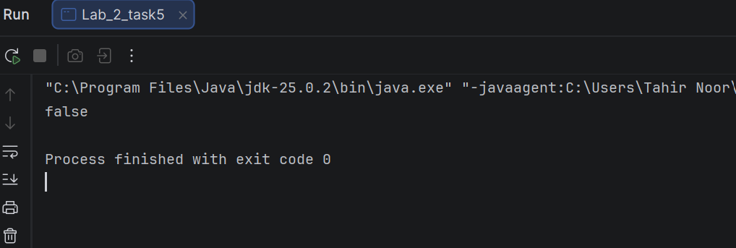

Task No. 6:
Personalized Greeting (Strings & Concatenation) Objective: Use different methods of string joining.
• Create variables for greeting, firstName, and lastName.
• Use the + operator to join them for one output.
• Use the .concat() method to join them for a second output.
Solution:

public class Lab_2_task6
{
public static void main(String[] args)
{
String greeting = "Name";
String firstname = "Tahir";
String lastname = "Noor";
System.out.println(greeting+" "+ firstname+" "+lastname);
System.out.println(greeting.concat(" ").concat(firstname).concat(" ").concat(lastname));
}
}
Output:

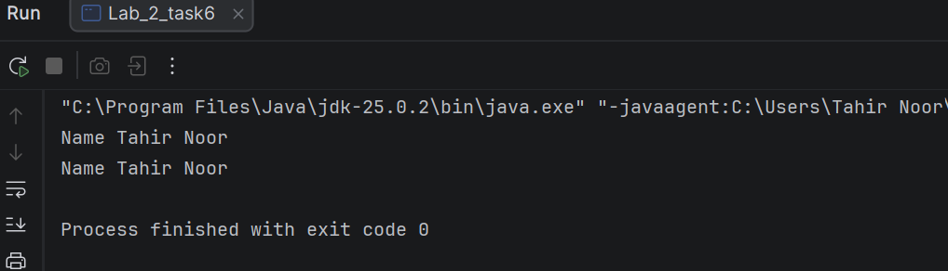

Task No. 7:
Time-of-Day Identifier (If...Else If) Objective: Use conditional chains.
• Store an int variable hour (0 to 23).
• If hour is between 5 and 11, print "Good Morning".
• Else if hour is between 12 and 17, print "Good Afternoon".
• Else if hour is between 18 and 23, print "Good Evening".
• Use else to handle any other numbers as "Invalid Hour".

Solution:

public class Lab_2_task7
{
public static void main(String[] args)
{
int hour = 9;
if (hour >= 5 && hour <= 11)
{
System.out.println("Good morning");
}
else if (hour >= 12 && hour <= 17)
{
System.out.println("Good afternoon");
}
else if (hour >= 18 && hour <= 23)
{
System.out.println("Good evening");
}
else
{
System.out.println("Invalid hour");
}
}
}
Output:

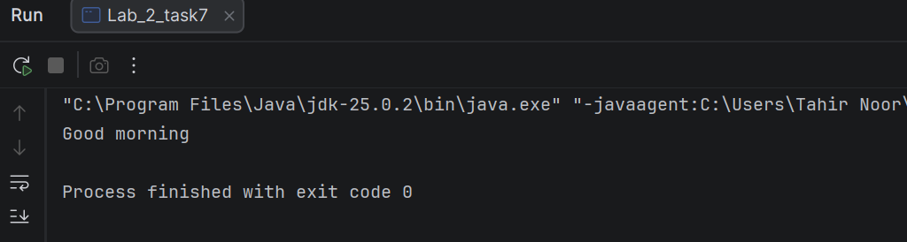

Task No. 8:

The Currency Switcher (Switch Case) Objective: Practice multi-way branching.
• Create a variable String currency = "USD".
• Use a switch statement to print the full name of the currency:
o "USD" -> "United States Dollar"
o "GBP" -> "British Pound"
o "EUR" -> "Euro"
o Default -> "Unknown Currency" Task 9: Comparison & Increment Lab (Operators) Objective:

Solution:

public class Lab_2_task8

{
public static void main(String[] args)
{
String currency="EUR";
switch (currency)
{
case "USD":
System.out.println("United states dollar");
break;
case "GBP":
System.out.println("British Pound");
break;
case "EUR":
System.out.println("Euro");
break;
default:
System.out.println("Unknown currency");
}
}
}
Output:

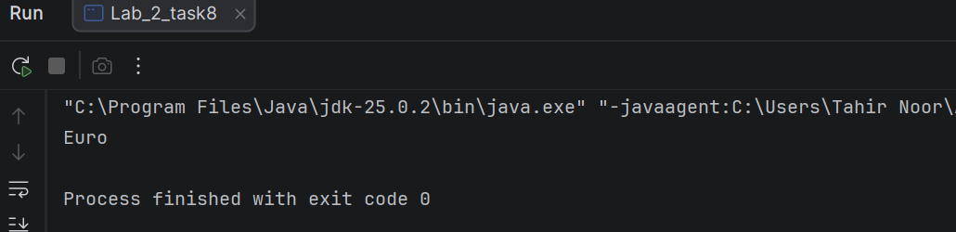

Task No. 9:

Understand how values change.
• Declare int x = 10 and int y = 20.
• Use a comparison operator to print if x is not equal to y.
• Apply the increment operator ++ to x.
• Print the new value of x and check if it is now greater than 10.

Solution:

public class Lab_2_task9
{
public static void main(String[] args)
{
int x=10;
int y=20;
if (x!=y)
{
System.out.println("x is not equal to y");
}
x++;
System.out.println(x);
if (x>10)
{
System.out.println("Now x is greater than 10");
}
}
}

Output:

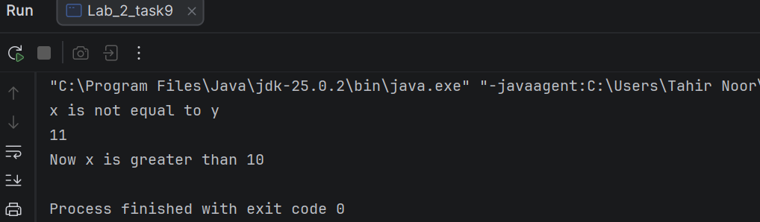

Lab Evaluation:

Course Name: Object Oriented Programming |  |  |  | Course Code: CMPE221L
Assignment Type: Lab |  |  |  | Dated: 2nd March 2026
Semester: 3rd |  |  |  | Session: 2025
Lab/Project/Assignment #: 3 |  |  |  | CLOs to be covered: CLO1
Lab Title: Getting Started with JAVA |  |  |  | Teacher Name : Mr. Shahmeer Nawaz
CLO1 | Implement abstraction and encapsulation to develop reusable classes for objects of real-world problems
Levels (Marks) | Level1 | Level2 | Level3 |  | Level4 | Level5 | Level6
(10)
Total |  |  |  |  |  |  | /10

Rubrics for Current Lab Evaluation
Scale | Marks | Level | Rubric
Excellent | 9-10 | L1 | Submitted all lab tasks, BONUS task, have good understanding.
Very Good | 7-8 | L2 | Submitted the lab tasks but have good understanding
Good | 5-6 | L3 | Submitted the lab tasks but have weak understanding.
Basic | 3-4 | L4 | Submitted the lab tasks but have no understanding.
Barely  Acceptable | 1-2 | L5 | Submitted only one lab task.
Not Acceptable | 0 | L6 | Did not attempt

LAB No. 3
Lab Goals/Objectives:
- Getting Started with Java
- Acquiring practice with familiar programming constructs in JAVA

University Of Engineering and Technology, Lahore
Computer Engineering Department
Equipment Required: Inteli J IDEA Edition Community, Net Beans with JDK 13 Version, Visual Studio.
Theory/Relevant Material: Write First Java Program
- Modify the Point class as discussed in class: that can represent 3-D point. Modify all the existing functions such that they work for 3-D point as well.
- Think of Time as an entity. Think of attributes and functions. Implement getter setters for its attributes. And write a function whatTime( int no_of_seconds_till_noon) and sets its attributes accordingly.
- You have graduated from University and now have a great job! You want to save for buying some physical asset(like house , car, Alienware or macbook etc). Now assets are never cheap, you realize you are going to have to save for several years before you can afford to make the down payment on it. We want to determine how long it will take you to save enough money to make the down payment given the following assumptions: i. Call the cost of your dream asset total_cost.
    - Call the portion of the cost needed for a down payment portion_down_payment. For simplicity, assume that portion_down_payment = 0.25 (25%) of the total_cost.
    - Call the amount that you have saved thus far current_savings. You start with a current savings of $0.
    - Assume that you invest your current savings wisely, with an annual return of r (in other words, at the end of each month, you receive an additional current_savings*r/12 funds to put into your savings – the 12 is because r is an annual rate). Assume that your investments earn a return of r = 0.04 (4%).
    - Assume your monthly salary is monthly_salary.
    - Assume you are going to dedicate a certain amount of your salary each month to saving for the down payment. Call that portion_saved. This variable should be in decimal form (i.e. 0.1 for 10%).
    - At the end of each month, your savings will be increased by the return on your investment, plus a percentage of your monthly salary (annual salary / 12).
Write a program to calculate how many months it will take you to save up enough money for a down payment. You will want your main variables to be floats, so you should cast user inputs to floats.
Your program should ask the user to enter the following variables:
  - The starting monthly salary (monthly_salary)
  - The portion of salary to be saved (portion_saved)
  - The cost of your dream home (total_cost)

Try different inputs and see how long it takes to save for a down payment.

Sample input

>>>

Enter your monthly salary: 10000
Enter the percent of your salary to save, as a decimal: .10 Enter the cost of your dream home: 1000000
Number of months: 183
>>>

Enter your monthly salary: 6666.66
Enter the percent of your salary to save, as a decimal: .15 Enter the cost of your dream home: 500000 Number of months: 105 >>>

Task No. 1:
Modify the Point class as discussed in class: that can represent 3-D point. Modify all the existing functions such that they work for 3-D point as well.
Solution:
public class Lab_3_3D_PointTask
{

public static void main(String[] args) {

class Point {
private int a=3;
private int b=4;
private int c=6;

public Point()
{
a = 3;
b = 4;
c = 6;
}
public Point(int a, int b, int c) {
this.a = a;
this.b = b;
this.c = c;
}

public int getA() { return a; }
public void setA(int a) { this.a = a; }

public int getB() { return b; }
public void setB(int b) { this.b = b; }

public int getC() { return c; }
public void setC(int c) { this.c = c; }
}

Point p1 = new Point();
Point p2 = new Point();
Point p3 = new Point();

System.out.println(p1.getA());
System.out.println(p2.getB());
System.out.println(p3.getC());
System.out.println(p1.getA() + " " + p1.getB() + " " + p1.getC());
}
}

Output: 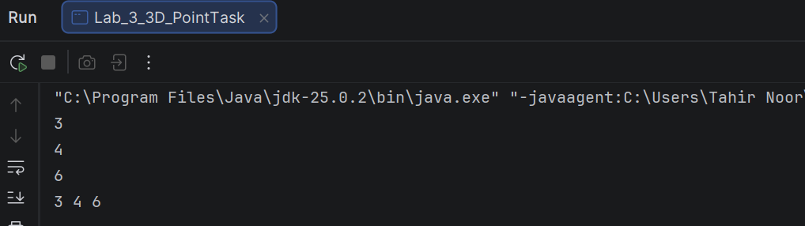

Task No. 2:
Think of Time as an entity. Think of attributes and functions. Implement getter setters for its attributes. And write a function whatTime( int no_of_seconds_till_noon) and sets its attributes accordingly.
Solution:
public class Lab_3_Time
{
static class Time
{
private int h;
private int m;
private int s;

public int getH() { return h; }
public void setH(int h) { this.h = h; }

public int getM() { return m; }
public void setM(int m) { this.m = m; }

public int getS() { return s; }
public void setS(int s) { this.s = s; }

public void what_Time(int no_of_sec) {
int total_sec = 43200 - no_of_sec;
h = total_sec / 3600;
int remaining = total_sec % 3600;
m = remaining / 60;
s = remaining % 60;

System.out.print(h+ ":" +m+ ":" +s+ " ");
if (h < 12) {
System.out.println("am");
} else {
System.out.println("pm");
}
}
}

public static void main(String[] args) {
Time t1 = new Time();
t1.what_Time(5000);
}
}
Output:

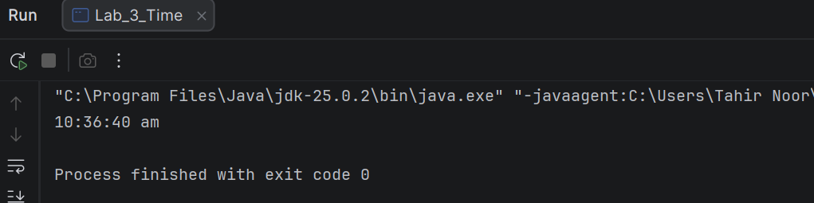

Task No. 3:
You have graduated from University and now have a great job! You want to save for buying some physical asset(like house , car, Alienware or macbook etc). Now assets are never cheap, you realize you are going to have to save for several years before you can afford to make the down payment on it. We want to determine how long it will take you to save enough money to make the down payment given the following assumptions: i. Call the cost of your dream asset total_cost.
Solution:
import java.util.Scanner;
public class Lab_3_SalaryTask{
public static void main(String[] args)
{
Scanner sc = new Scanner(System.in);
float monthly_salary, portion_saved, total_cost, portion_down_payment = 0.25f, r = 0.05f, current_saving = 0;
int months = 0;
{
System.out.println("Monthly salary:");
monthly_salary = sc.nextFloat();
System.out.println("Portion of salary to save (e.g. 0.15 for 15%):");
portion_saved = sc.nextFloat();
System.out.println("Total cost of your dream asset:");}
total_cost = sc.nextFloat();
float down_payment = total_cost * portion_down_payment;
while (current_saving < down_payment) {
current_saving += current_saving * r / 12;
current_saving += monthly_salary * portion_saved;
months++;
}
{
System.out.println("Months needed to save for down payment: " + months);
}}}
Output:

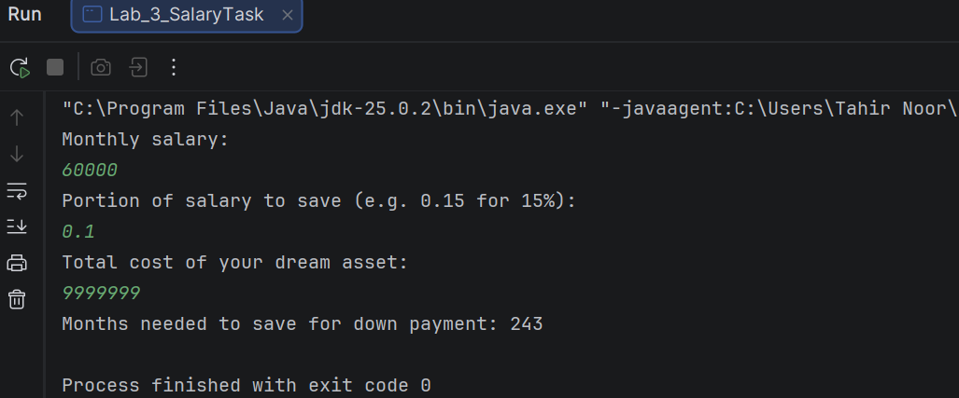

Lab Evaluation:

Course Name: Object Oriented Programming |  |  |  | Course Code: CMPE 221L
Assignment Type: Lab |  |  |  | Dated: 09th March 2026
Semester: 2rd |  |  |  | Session: 2025
Lab/Project/Assignment #: 4 |  |  |  | CLOs to be covered: CLO1
Lab Title: Classes & Objects |  |  |  | Teacher Name : Mr. Shahmeer Nawaz
CLO1 | Implement abstraction and encapsulation to develop reusable classes for objects of real-world problems
Levels (Marks) | Level1 | Level2 | Level3 |  | Level4 | Level5 | Level6
(10)
Total |  |  |  |  |  |  | /10

Rubrics for Current Lab Evaluation
Scale | Marks | Level | Rubric
Excellent | 9-10 | L1 | Submitted all lab tasks, BONUS task, have good understanding.
Very Good | 7-8 | L2 | Submitted the lab tasks but have good understanding
Good | 5-6 | L3 | Submitted the lab tasks but have weak understanding.
Basic | 3-4 | L4 | Submitted the lab tasks but have no understanding.
Barely  Acceptable | 1-2 | L5 | Submitted only one lab task.
Not Acceptable | 0 | L6 | Did not attempt

LAB No. 4
Lab Goals/Objectives:
- Basic OO programming in java
- Objects and Classes
University Of Engineering and Technology, Lahore
Computer Engineering Department
Equipment Required: Inteli J IDEA Edition Community, Net Beans with JDK 13 Version, Visual Studio.
Theory/Relevant Material: Objects and classes, constructors, getter & setters, modifiers
- Thinking of Time as an entity JTime class was created. Each object of this class represents a time-stamp (a mark in history). It has three attributes (hour, minute, second) and three constructors along with some other functions. Enhance its functionality by added following functions to it and test the functionality by updating the driver function.
  - Add a function that finds the time elapsed in seconds between two time-stamps.
  - Add a function that finds the time elapsed in two time-stamps in format of another time-stamp.
  - Add another constructor that takes total number of seconds elapsed after 12 am and construct the timestamp accordingly.
- We are going to develop a menu-driven application to manage a simple bank account class. It supports the following operations
  - Deposit money (to add an amount in current balance)
  - Withdraw money (to subtract an amount from the current balance)
  - Check balance (to display current balance of customer)
Note: Use a Switch statement to enter the choice of operation from the user. For initially create a function withname saving account to store the current balance of the customer. Write a Java class along with a driver program to test it.
Something is Brewing:

- So lately Ali has been walking as per your instructions. Avoiding obstacles in its path. Now Hasan wants to startwalking with Ali. But Hasan will walk randomly and will avoid the same obstacles as Ali. Write a code that will simulate both the walk patterns of Ali and Hasan simultaneously. Output can e of the form:
Starting: Ali's Location is = (0 : 0) Hassan's Location is = (0 : 0) Hasan has Random Movement, Ali follows order
ALi: Where should i go now: v Ali is at = (0 : -1) Hasan is at = (0 : 1)
ALi: Where should i go now: ^ Ali is at = (0 : 0)
Hasan is at = (0 : 2)

ALi: Where should i go now: ^ Ali is at = (0 : 1)
Hasan encounters hurdle at (1:2) Hasan is at = (0 : 2)

Task No. 1:

Thinking of Time as an entity JTime class was created. Each object of this class represents a time-stamp (a mark in history). It has three attributes (hour, minute, second) and three constructors along with some other functions. Enhance its functionality by added following functions to it and test the functionality by updating the driver function.

Solution:
public class Lab_4_TimeEntity
{
static class JTime
{
public int hour;
public int min;
public int sec;
public JTime()
{
this.hour = 0;
this.min = 0;
this.sec = 0;
}
public JTime(int hour, int min, int sec) {
this.hour = hour;
this.min = min;
this.sec = sec;
}
public JTime(int totalSeconds) {
this.hour = totalSeconds / 3600;
int remaining = totalSeconds % 3600;
this.min = remaining / 60;
this.sec = remaining % 60;
}
public void display() {
System.out.printf( hour+":" +min+":" +sec);
}
private int toSeconds() {
return hour * 3600 + min * 60 + sec;
}
public int elapsedSeconds(JTime t) {
return Math.abs(this.toSeconds() - t.toSeconds());
}
public JTime elapsedTime(JTime t) {
return new JTime(this.elapsedSeconds(t));
}
}
public static void main(String[] args) {
JTime t1 = new JTime();
{
t1.hour = 10;
t1.min = 15;
t1.sec = 30;
JTime t2 = new JTime();
t2.hour = 12;
t2.min = 45;
t2.sec = 50;
System.out.print("Time 1 = ");
t1.display();
System.out.println();
System.out.print("Time 2 = ");
t2.display();
System.out.println();
System.out.println("Elapsed seconds = " + t1.elapsedSeconds(t2));
System.out.print("Elapsed time = ");
t1.elapsedTime(t2).display();
System.out.println();
}
JTime t3 = new JTime(5000);
System.out.print("Time from 5000 seconds = ");
t3.display();
System.out.println();
}
}
Output:

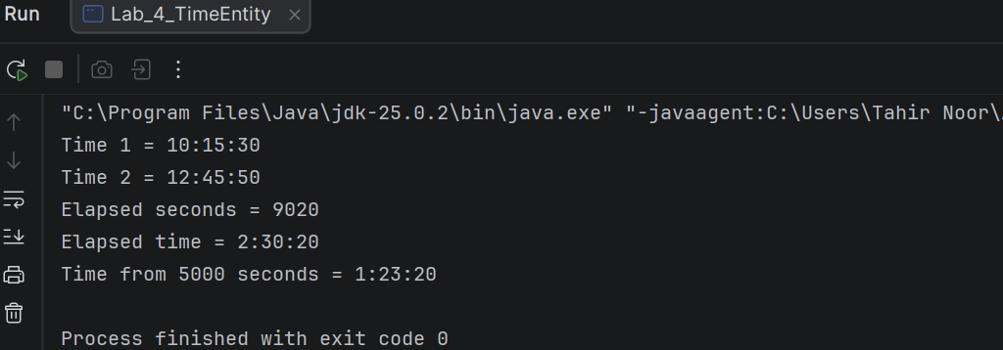

Task No. 2:

We are going to develop a menu-driven application to manage a simple bank account class. It supports the following operations
Solution:
import java.util.Scanner;
public class Lab_4_BankAccount
{
int saving_account = 0;
void deposit(int amount)
{
saving_account += amount;
System.out.println("Amount Deposited: " + amount);
}
void withdraw(int amount)
{
if (amount <= saving_account)
{
saving_account -= amount;
System.out.println("Amount Withdrawn: " + amount);
}
else
{
System.out.println("Insufficient Balance!");
}
}
void checkBalance()
{
System.out.println("Current Balance: " + saving_account);
}
public static void main(String[] args)
{
Scanner sc = new Scanner(System.in);
Lab_4_BankAccount obj = new Lab_4_BankAccount();
int choice;
do
{
System.out.println("\n1.Deposit\n2.Withdraw\n3.Check Balance\n4.Exit");
System.out.print("Enter choice: ");
choice = sc.nextInt();
switch (choice)
{
case 1:
obj.deposit(sc.nextInt());
break;
case 2:
obj.withdraw(sc.nextInt());
break;
case 3:
obj.checkBalance();
break;
case 4:
System.out.println("Exiting...");
break;
default:
System.out.println("Invalid CHOICE");
}
} while (choice != 4);
sc.close();
}
}

Output:

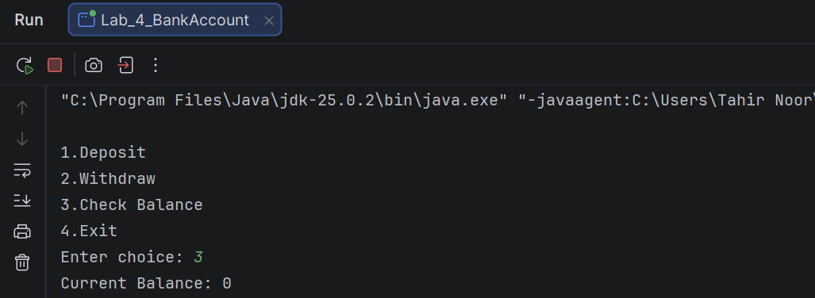

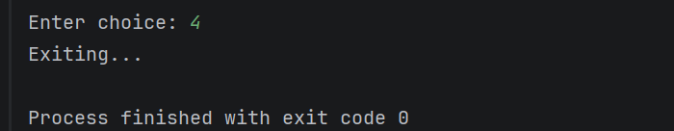

Task No. 3:

So lately Ali has been walking as per your instructions. Avoiding obstacles in its path. Now Hasan wants to startwalking with Ali. But Hasan will walk randomly and will avoid the same obstacles as Ali. Write a code that will simulate both the walk patterns of Ali and Hasan simultaneously. Output can e of the form:

Solution:
import java.util.Random;
public class Lab_4_WalkPattern {
public static void main(String[] args) {
int aliX = 0, aliY = 0;
int hasanX = 0, hasanY = 0;
char[] aliMoves = {'v', '^', '^', '>'};
Random rand = new Random();
System.out.println("Starting: Ali = (0 : 0), Hasan = (0 : 0)");
for (char move : aliMoves) {
if (move == 'v') aliY -= 1;
else if (move == '^') aliY += 1;
else if (move == '<') aliX -= 1;
else if (move == '>') aliX += 1;
boolean valid = false;
while (!valid) {
int dir = rand.nextInt(4);
int newX = hasanX;
int newY = hasanY;
if (dir == 0) newX++;
else if (dir == 1) newX--;
else if (dir == 2) newY++;
else newY--;
if (newX != aliX || newY != aliY) {
hasanX = newX;
hasanY = newY;
valid = true;
}
}
System.out.println("Ali moves " + move + " -> Ali = (" + aliX + " : " + aliY + ")");
System.out.println("Hasan -> Hasan = (" + hasanX + " : " + hasanY + ")");
}
}
}
Output:

